**OBSERVATION SHEET – GEOLAND**

|  |  |  |  |
| --- | --- | --- | --- |
| Date: | | | ID observation (letter transect + number sample): |
| Hour: | | | Place (village): |
| Observers: |  | | |
| GPS | X – coordinate: | |  |
| Y- coordinate: | |  |
| Z-coordinate: | |  |
| Distance to previous sample point (m) | | |  |
| Weather conditions: | |  | |
| Photograph numbers: | |  | |

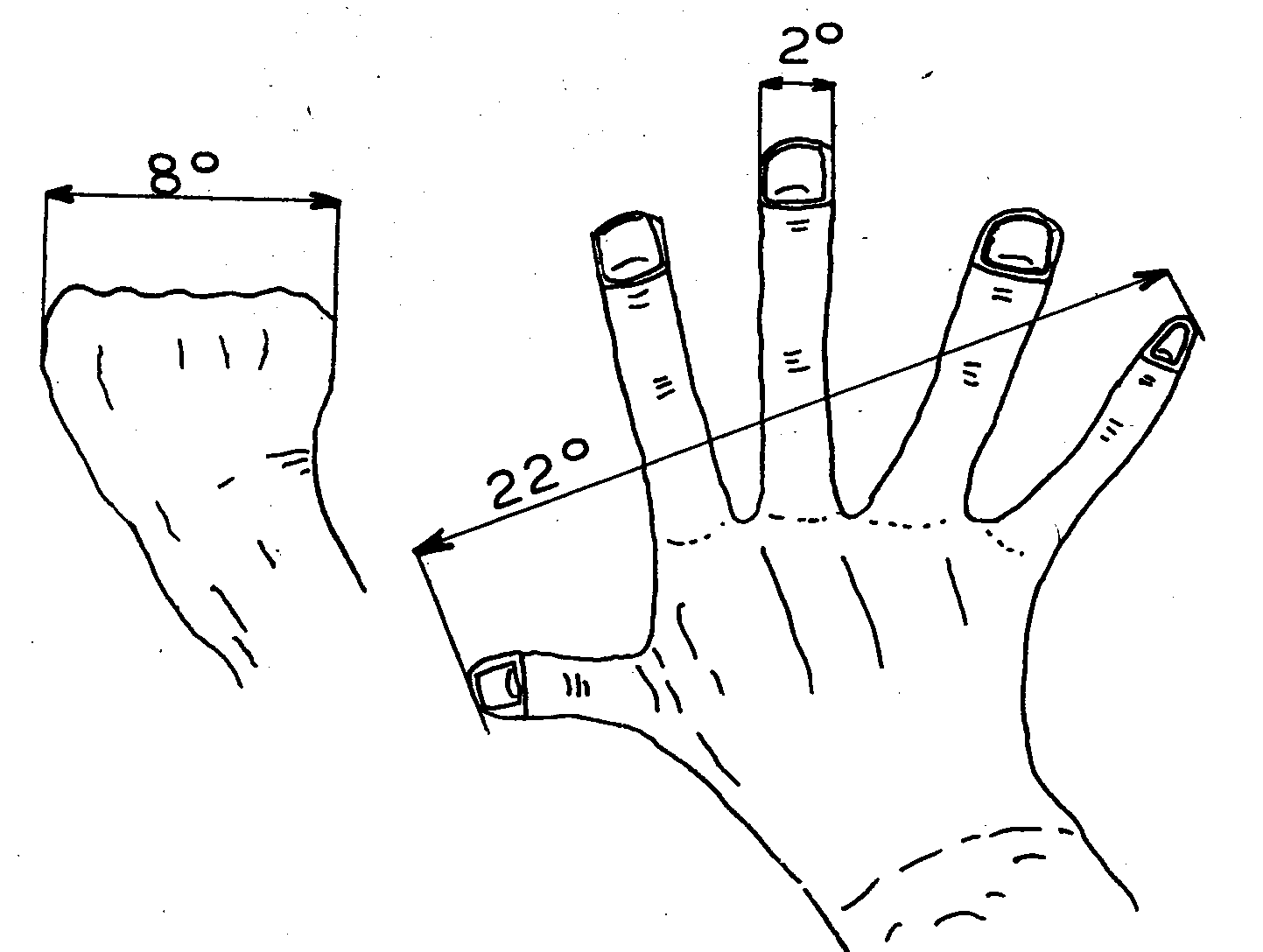

1. Topography: (1) flat (2) slope (N S E W) (3) undulating

In case of slope: concave – convex

1. Slope: (1) 0-2° (2) 2-8° (3) 8-22° (4) > 22°

Exact percentage or degrees (to be calculated based on XYZ coordinates)

1. Soil

Moisture conditions: |----------------------------------------------------------------------|

(circle along the gradient) **dry wet**

Colour soil (Munsell scale code):

|  |  |  |  |  |
| --- | --- | --- | --- | --- |
| Top-soil conditions:  (circle one or more options) | (1) bare bedrock  (> 75%) | (2) bedrock, partially bare (50/50%) | (3) loose soils dominating (>75%): gravel, clay, sand, loam, marl  (circle one or more options) | (4) man-made, anthropogenic |

Other bedrock, soil or topography observations of the site (erosion, weathering, deposition):

1. Vegetation

|  |  |  |
| --- | --- | --- |
|  | | If yes, specify |
| Ground layer coverage: | (1) bare % |  |
| (2) grass % |  |
| (3) herbs % |  |
| (4) cultivated % |  |

Number of tree & scrub layers: 0 1 2 more

Layer heights: (1) < 0,3m (2) 0,3-0,6m (3) 0,6-2m (4) 2-5m (5) > 5m

Coverage: (1) open <25% (2) semi-open 25-50% (3) semi-closed 50-75% (4) closed >75%

Spatial distribution: (1) continuous (2) uneven (3) patchy

1. Management

|  |  |
| --- | --- |
| What are the current land use activities in this area? |  |
| Are there any evidences of past land uses in the site today? |  |
| Are there any animals? Which and how much? |  |

1. Conclusion

|  |  |  |  |  |  |  |
| --- | --- | --- | --- | --- | --- | --- |
| General Habitat category | Global/env. qualifier | Site qualifier | Man. qualifier | Life form/species | | Comment |
| Life form % | Species % |
|  |  |  |  |  |  |  |